Assignment 02 exercise

FAHEEM AKBAR

CMS ID : 023-23-0365

DSA ASSIGNMENT 02 || Submitted to ma’am Marina Gul

**Assignment: 02**

Generic Linked List Generics means parameterized types. The idea is to allow type (Integer, String, … etc., and user-defined types) to be a parameter to methods, classes, and interfaces. Using Generics, it is possible to create classes that work with different data types. An entity such as class, interface, or method that operates on a parameterized type is a generic entity. we use <> to specify parameter types in generic class creation.

To create objects of a generic class, we use the following syntax.

Solution: To implement a generic linked list in Java, we need to create a LinkedList class that can store elements of any type. This means we'll make use of Java Generics to create a linked list that can be parameterized by any data type (e.g., Integer, String, CustomClass, etc.).

Below is the implementation of a simple generic linked list in Java:

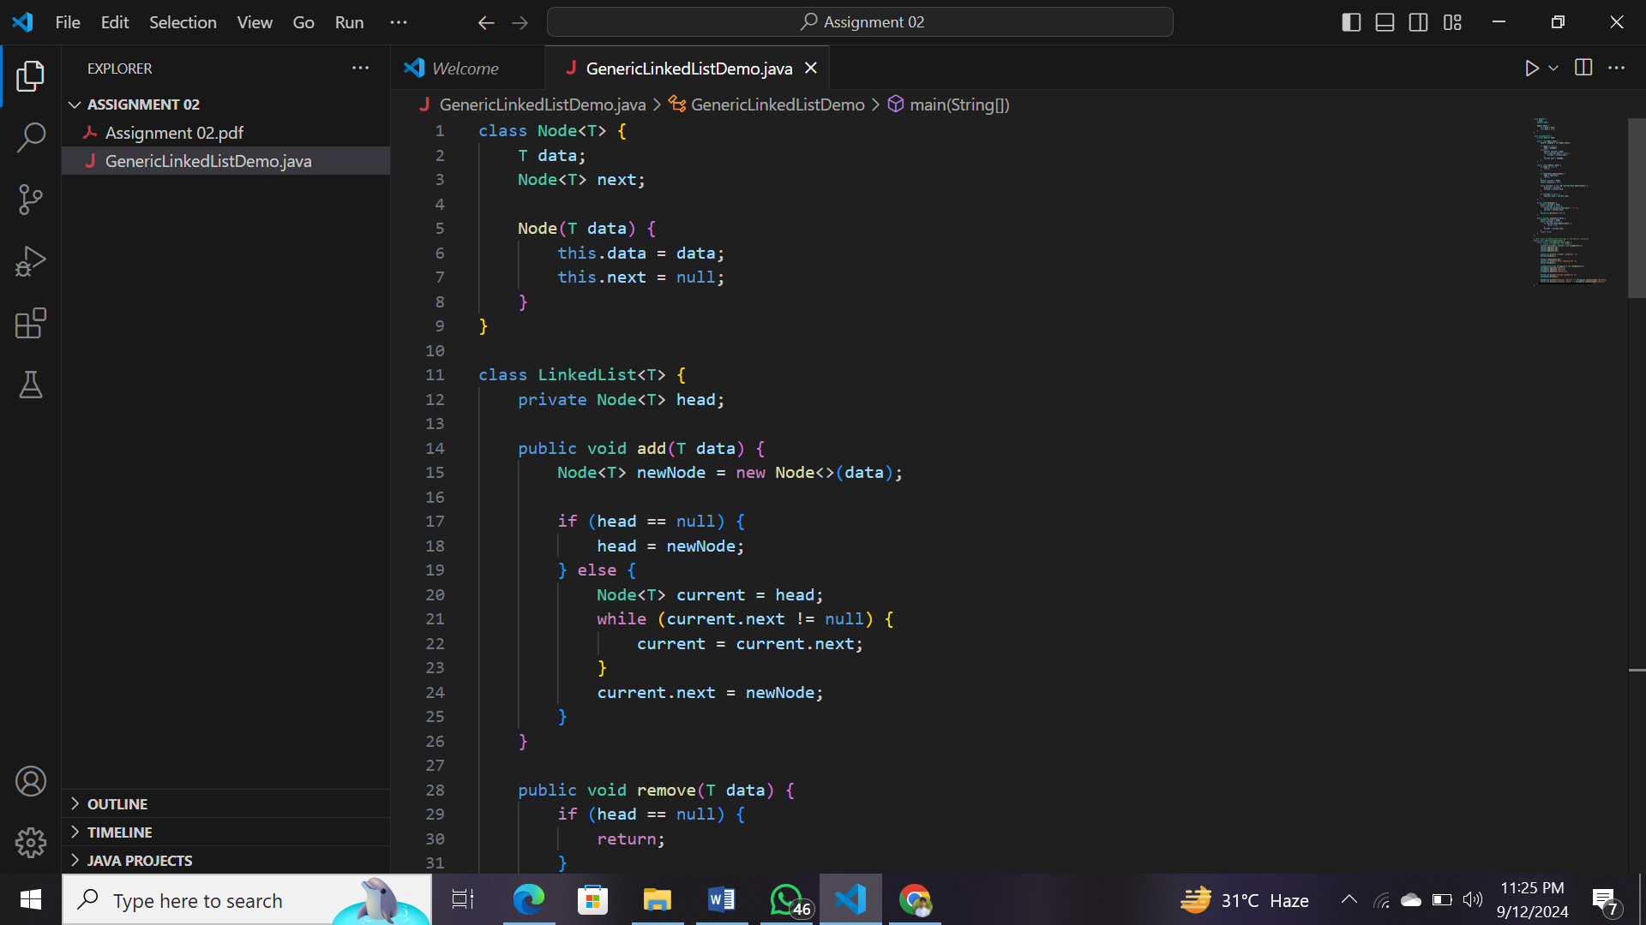

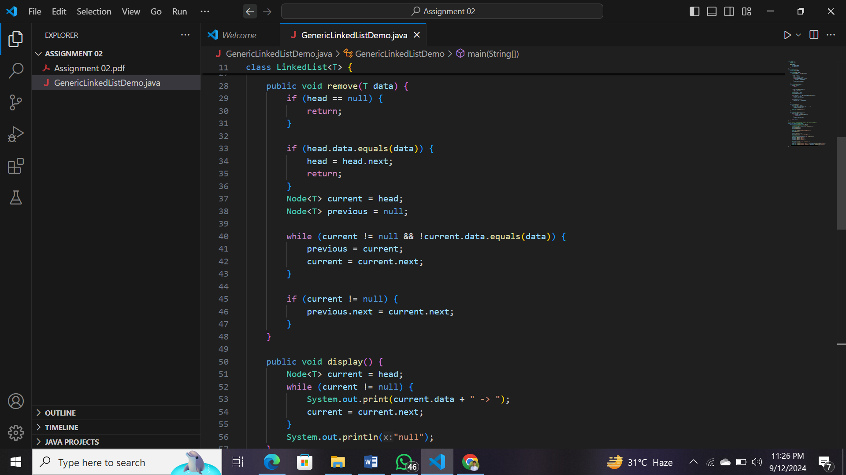

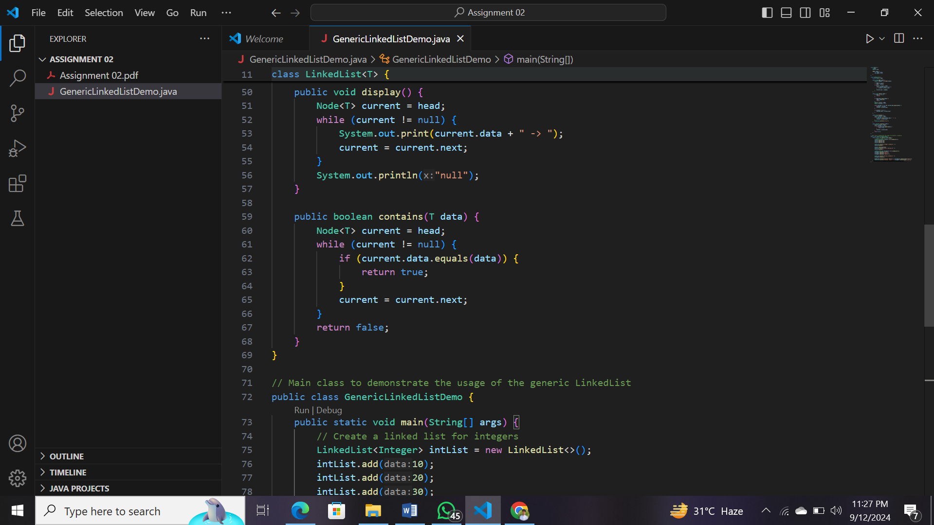

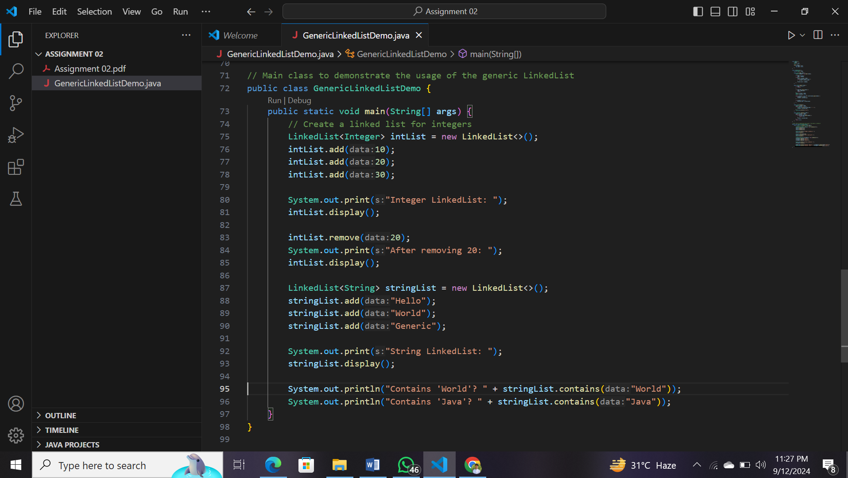

OUTPUT:

